
Department of Building Safety Policy and Procedure Statement
FROM: Chad Root, CBO

SUBJECT: Hot Tub Safety and Disconnects/ Emergency Shut Offs

DATE: November 13, 2017

Purpose: The Louisville Building Department shall begin to implement and enforce a provision that may not have been enforced in the past under the State of Colorado adopted code under the National Electrical Code that requires all types of construction that have hot tubs to have an emergency shut off 5 ft. to 50 ft. within sight of the tub. This requirement does not apply to one-family dwellings. One-family dwellings are defined as buildings constructed under the International Residential Code IRC all other must have Emergency Shutoff switch per 680.40 of the NEC. Disconnects for hot tubs/ spas in all construction types shall not be located under tubs as this is in violation of the IRC and NEC of the 5 ft. rule. However disconnects can be located greater than 5 ft. in line of sight from the waters edge in an radius formation up to 6ft. on a wall. The placement of a hot tub must ensure that occupants sitting on the edge of a hot tub will not fall over any guardrails if the deck/patio/roof top is greater than 30" above grade.

Policy: This policy is to give guidance of what is a one-family dwelling and as to where disconnects to hot tubs can be located. Per the adopted Building Code the placement of and height of guardrails are to ensure that occupants sitting on the edge of the hot tub will not fall over the guardrail. Guardrail Height: To figure out if the guardrail is tall enough the guardrail measurement will be taken in an arch fashion

from top edge of the hot tub toward the guardrail. Residential tubs need
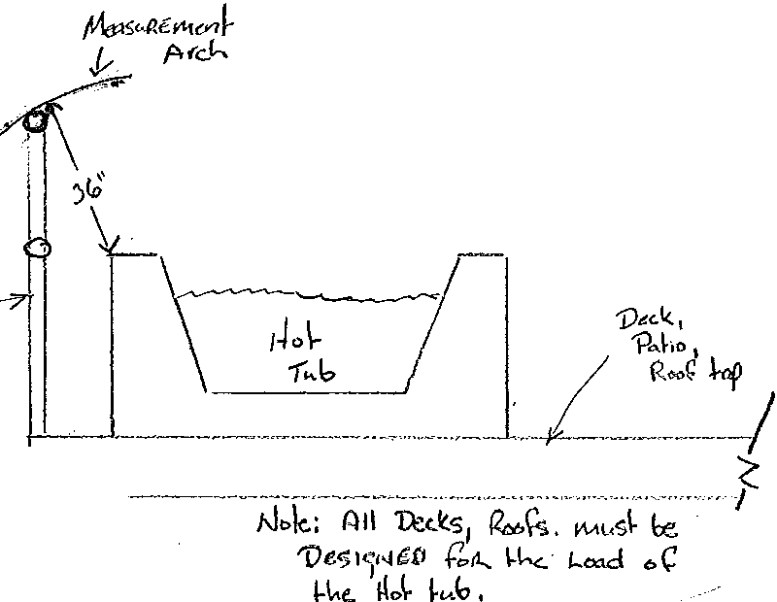
36" from edge of tub or greater to the top of guardrail and commercial applications need 42". Attached is a diagram to better describe this requirement.

.

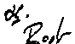

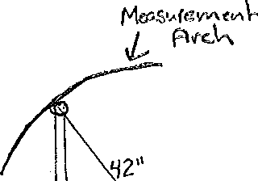
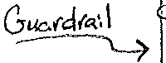


------- =---- -== = = =-==- =1
1----- l
C,r,.l.a.. "\c\e:, AI\ Th% <J, ,\'., "'d
"'"' 4h..dc.f<'I ?..•o'il MV", be.
.:Jo" G"'j' V\(er.Ct1 ( a.. 1'\J. \. (,.;; .
.n.""'
Gr<'<k

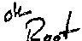
-----1l

