SUBJECT: Ordinance 1897, series 2025 – An ordinance amending title 17 of the LOUISVILLE MUNICIPAL CODE (LMC) TO UPDATE PARKING MINIMUMS FOR MULTIFAMILY AND ADAPTIVE REUSE DEVELOPMENT TO COMPLY WITH COLORADO HB24-1304

DATE: July 8, 2025

Prepared By: MATT POST, SENIOR PLANNER

Presented By: MATT POST, SENIOR PLANNER

SUMMARY:
In 2024, the Colorado General Assembly adopted House Bill 24-1304 requiring local governments within Metropolitan Planning Organizations (MPOs) to eliminate minimum parking requirements for new multifamily and residential adaptive reuse developments within designated Applicable Transit Service Areas (ATSAs).

The City of Louisville is located within a Denver Regional Council of Governments MPO, and a total of 44 transit stops that qualify as ATSAs have been identified within the City’s jurisdiction.

HB24-1304 prohibits local governments within MPOs from enacting or enforcing these minimum parking requirements on or after June 30, 2025. The law was adopted with the intent of reducing the overall cost of housing, increasing development feasibility, and promoting a shift toward multi-modal transportation options. To comply with the law, staff are proposing amendments to Title 17 of the Louisville Municipal Code (LMC), which will remove minimum parking requirements for the specified land uses located within identified ATSAs.

BACKGROUND / PRIOR DISCUSSIONS:
HB24-1304 applies to properties within the city that at least partially intersect with areas identified as having Applicable Transit Service, which are defined as areas that are within one-quarter mile of a transit stop that provides service at intervals of 30 minutes or less during peak hours. In Louisville, this includes areas within one-quarter mile of Regional Transportation District (RTD) transit stops, including the DASH route, Route 228 (Lafayette/Louisville/Broomfield), and the Flatiron Flyer stop at US 36 and McCaslin Blvd.

For properties within these ATSAs, the bill prohibits local governments from enforcing or requiring minimum off-street parking for:

- New multifamily residential and the residential portion of new mixed-use residential developments; and
- Adaptive reuse projects converting buildings for residential use; and
- Adaptive reuse projects that are at least 50% residential in use, including all uses in such buildings.

Applicable Transit Service Areas were developed and determined by the Colorado Department of Local Affairs, in collaboration with CDOT, the Colorado Energy Office, and RTD. Applicable Transit Service Areas include locations within one-quarter mile of:

- Existing commuter bus rapid transit stations, such as those served by RTD’s Flatiron Flyer routes; and
- Bus stops on routes with weekday service every 30 minutes or more for at least four hours, either already operating or planned for implementation by 2030, such as those served RTD’s Dash route.
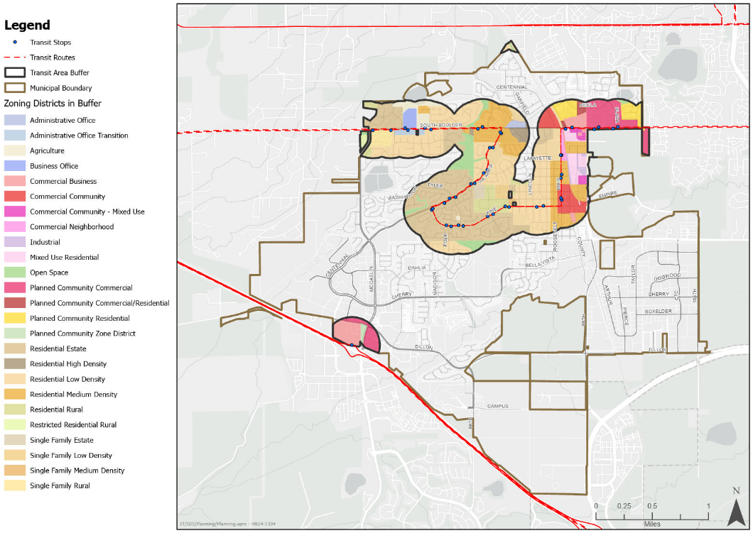
Applicable Transit Service Areas in Louisville

Although the law prohibits a local jurisdiction from enforcing minimum parking requirements on multifamily and adaptive reuse development projects within an ATSA, a developer may voluntarily provide off-street parking for such developments. The law further clarifies that nothing prevents a local jurisdiction from:

- Parking compliance with affordable housing funding conditions. If the City or a developer has obtained funding for affordable housing development which requires a minimum number of parking spaces, the City may enforce parking requirements necessary to comply with funding conditions.
- Requiring bicycle parking.
- Requiring accessible (ADA) parking spaces and electric vehicle charging stations when a developer voluntarily provides on-site parking.

Definition of Multifamily and Alignment with HB24-1304

HB24-1304 does not include a specific definition of multifamily housing. However, guidance from the Colorado Department of Local Affairs (DOLA) indicates that local jurisdictions may apply their own definition of multifamily (or similar) provided that the definition does not differ substantially from the State’s definition. Under C.R.S. § 38-45-101, the State of Colorado defines multifamily as “any improved real property used or intended to be used as a residence and that contains more than one dwelling unit. Multi-family dwelling includes a condominium or cooperative”.

The Louisville Municipal Code currently defines a “multi-unit or multifamily dwelling” as a “building used by two or more families living independently of each other in separate dwelling units, but does not include hotels, motels or resorts”. This definition closely aligns with the State’s definition of multifamily housing under C.R.S. § 38-45-101. As such, staff do not recommend any changes to the City’s existing definition for the purposes of complying with HB24-1304. The term “multi-unit” will be used throughout this report, and for review and use determination purposes, as it is the general use term that aligns with the definition referenced throughout multiple sections of the LMC.

For new mixed-use buildings, HB24-1304 applies only to the multi-unit residential portion, allowing the City to continue enforcing minimum parking requirements for the nonresidential components of such developments. However, in the case of adaptive reuse projects, where at least 50% of the existing building is converted to residential use, the law prohibits the City from imposing minimum parking requirements for any portion of the building, including the nonresidential uses.

The law defines “adaptive reuse” as the “conversion of an existing structure from the use for which it was constructed to a new use by maintaining elements of the structure and adapting such elements to a new use”. Staff do not recommend adopting a separate definition at this time, as the term is generally self-explanatory and clearly implies the repurposing of an existing building for a different land use

Zoning and Case Review

Depending on the zoning district, multi-unit or mixed-use buildings that include residential uses may be permitted either by-right or through a Special Review Use (SRU) process.

In districts where SRU approval is required, proposals are subject to the review criteria set forth in LMC Sec. 17.40. These criteria are designed to ensure compatibility with the surrounding development context by considering the location and nature of the proposed use, the character of adjacent development, and any potential adverse impacts. The SRU process allows for additional review and consideration in established or transitional neighborhoods, helping to ensure that new development aligns with the intent and character of each zoning district. While staff will continue to apply these criteria as part of the SRU review, it is important to note that, in accordance with HB24-1304, parking may not be imposed as a condition of approval for any multi-unit or mixed-use residential development located within an ATSA.

In addition to SRU review, applicable zoning districts include density limitations aligned with the intent of each district, as outlined in LMC Sec. 17.12.010 – District Categories. Zoning districts where multi-unit dwellings are permitted as a Special Review Use include:

- Residential Estate (R-E)
- Residential Low Density (R-L)
- Residential Rural (R-R)
- Business Office (B-O)
- Commercial Business (C-B)
- Commercial Community (C-C)
- Commercial Neighborhood (C-N)

The following zoning districts permit multifamily dwellings as a by-right use. While these districts also include density limitations consistent with the intent of each district, they are generally considered appropriate for higher-density residential development.

- Residential Medium Density (R-M)
- Residential High Density (R-H)
- Mixed Use Residential (MU-R)
- Planned Community Commercial/Residential (PCZD)

While the City will continue to apply established zoning and SRU criteria to ensure context-sensitive development, HB24-1304 limits our ability to require off-street parking for qualifying projects within ATSAs.

ANALYSIS
The City of Louisville Housing Plan identifies several regulatory and economic barriers that limit the City’s ability to meet current and future housing needs. Among these, minimum parking requirements are recognized as a constraint to residential development, particularly for higher-density and income-restricted housing. The Housing Plan notes that existing minimum parking standards increase development costs, reduce buildable area on constrained sites, and negatively impact the financial feasibility of projects, especially in areas near transit where parking demand may be lower.

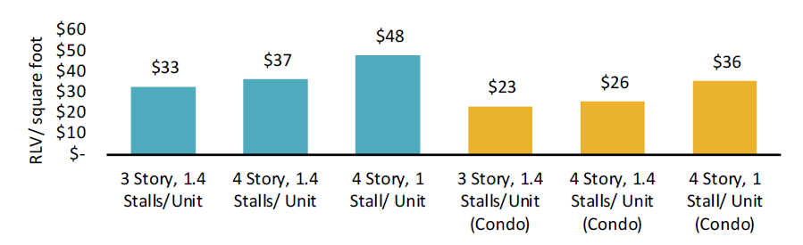
Modeling conducted as part of the Housing Plan’s feasibility analysis demonstrated that reducing parking requirements had a greater positive impact on project viability than increasing building height. Specifically, scenarios that reduced parking from 1.4 to 1 space per unit yielded higher residual land values for both rental and for-sale multifamily projects, thereby improving the financial feasibility of development and increasing the likelihood that such projects will move forward. The Plan further recommends reduced parking ratios and parking-related incentives in targeted areas such as transit corridors and Downtown Louisville, where walkability and access to multimodal transportation options can support lower vehicle dependence. These areas directly coincide with the ATSAs identified in HB24-1304 where enforcement of parking minimums is not prohibited.
Feasibility Results for Three- and Four-Story Multifamily Prototypes with Parking Reduction
The Housing Plan emphasizes the importance of revisiting parking requirements as part of a broader strategy to modernize the City’s zoning and land use regulations, and community engagement responses highlighted a desire for more flexible parking standards, especially near transit, as a way to support more affordable and diverse housing types.

While HB24-1304 prohibits the City from enforcing minimum off-street parking requirements for multi-unit developments within ATSAs, staff anticipate that most eligible projects will continue to include off-street parking on a voluntary basis. This expectation is supported by several industry-standard development considerations. First, market feasibility analyses routinely identify parking availability as a critical factor in project leasing and long-term occupancy, particularly in suburban communities such as the City of Louisville. Second, private financing entities, including construction lenders and long-term investors, often require some level of on-site parking as a condition of funding. These parties typically view the inclusion of parking as essential to maintaining the competitiveness and financial viability of a development. As such, while the City must comply with the prohibition on mandatory parking minimums, the practical realities of the development process are likely to result in the inclusion of off-street parking in most future development projects.

Staff recognize that the elimination of parking minimums may result in unintended consequences, including the potential for spillover parking in adjacent neighborhoods or commercial areas. However, the extent of any such impacts remains unknown at this time and will likely depend on the location, scale, and design of future development proposals as well as ongoing market behavior. Staff will continue to monitor conditions to consider policy responses.

2025 COUNCIL WORK PLAN:
This code amendment supports the 2025 City Council Work Plan by addressing two Council Priorities:

- Economic Vitality - this item is a targeted development code amendment to maintain a business-friendly approach by providing more flexibility for site planning with residential and mixed use buildings near transit.

- Housing – this item implements the Housing Plan through a development code amendment that supports more flexibility for off street parking, which can be one of the most significant barriers to building new, more affordable housing.

FISCAL IMPACT:
Budgeted?: Not Applicable

ALTERNATIVES:

The City Council may approve, approve with amendments, or deny the ordinance amendment.

Denial of the ordinance will leave the City in violation of HB24-1304. This may result in loss of eligibility for state funding and create legal challenges for the City.

PUBLIC COMMENTS:

No public comments have been received as of the date of this report.

PLANNINING COMMISSION RECOMMENDATION:
On May 8, 2025, The Planning Commission recommended approval of Resolution 8, Series 2025, approval of an ordinance amending Title 17 of the Louisville Municipal Code (LMC) concerning parking minimums for multifamily and adaptive reuse development to comply with HB24-1304.

STAFF RECOMMENDATION:
Staff recommend approval of Ordinance 1897, Series 2025, amending Title 17 of the Louisville Municipal Code (LMC) concerning parking minimums for multifamily and adaptive reuse development to comply with HB24-1304.

ATTACHMENTS:
- Ordinance 1897, Series 2025
- Resolution 8, Series 2025
- Planning Commission Minutes
- DOLA HB24-1304 Guide
- HB24-1304
- ATSA Map

